The International Partnership for Dogs (IPFD) was founded on August 28, 2014
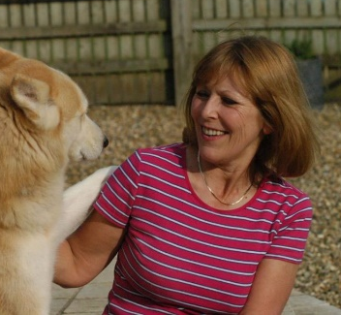
IPFD Officers, Board of Directors and Consultants - Alumni - 2014 - 2022
Caroline Kisko – Vice Chair, England 2014 - 19
Former The Kennel Club UK Secretary and Director of Communication

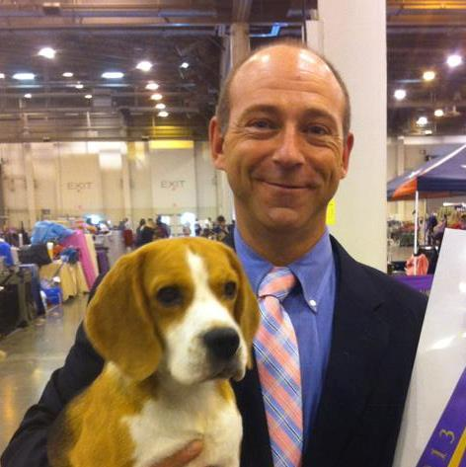
Eddie Dziuk – Board of Directors, USA 2014 - 17
Currently:
Chief Operating Officer, Orthopedic Foundation for Animals United States
Delegate, AKC
Member, Canine Health Committee, AKC
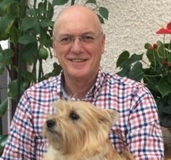
Jean-Pierre Genevois – Board of Directors, France 2014 - 19

Was listed as… Retired, Professor Emeritus
Member of the Scientific Commission of the Société Centrale Canine (French Kennel Club), in charge of hereditary joint diseases
Member of the International Elbow Working Group
Member of the European Society of Veterinary Orthopaedics and Traumatology.
Panelist for hip and elbow dysplasia screening, expert of the appeal procedure.
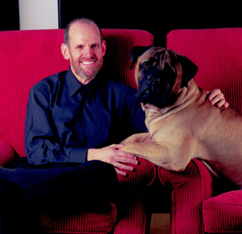
Alan Kalter – Board of Directors, USA 2015 - 17
Many AKC affiliations and Morris Animal Foundation affiliations
Alan is currently listed as the AKC Delegate from the American Bullmastiff Association.

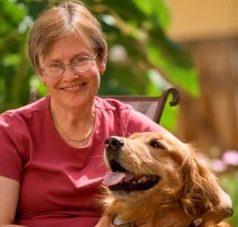
Patricia N. Olson – Board of Directors, USA 2014 - 19
Patricia N. Olson is a veterinarian and board certified in the specialties of theriogenology (reproduction) and animal welfare. She established and owned a veterinary clinic; was a tenured faculty member at Colorado State University’s College of Veterinary Medicine and Biomedical Sciences; served as the veterinary advisor for the International Air Transport Association; oversaw canine health, breeding and training at the largest guide dog school in North America (Guide Dogs for the Blind, Inc.); served as a congressional science fellow at the U.S. Senate; and was the former President/CEO of the largest non-profit research granting agency in the U.S. to advance health and welfare for companion animals and wildlife (Morris Animal Foundation). Dr. Olson recently founded the Animal Welfare Research Institute for the American Humane Association.

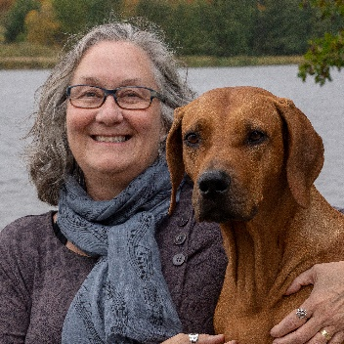
Brenda Bonnett – CEO, Veterinary Science Officer, Canada 2014 - 2022
As IPFD’s first Chief Executive Officer, Brenda was responsible for the development and operation of the IPFD including its technical infrastructure, partnership building, programs and projects, and more. She stepped down from the CEO role on 31 October, 2021 and continued to share her expertise with the international dog community as IPFD’s Veterinary Science Officer until July 2022. The wealth of information that Brenda and IPFD the team created during her tenure remain on DogWellNet.com as an enduring resource to support the health and welfare of dogs.
Formerly tenured faculty at the Ontario Veterinary College, Brenda is a veterinarian and Consulting Epidemiologist. Her research and projects in Europe and North America have included the development of national and international programs with kennel clubs; extensive work with / publications on animal insurance data; human-animal interactions, numerous pet welfare initiatives spanning the National Council on Pet Overpopulation (1993) and for the American Humane Association: Cat Welfare Forum (Sept. 2013) and Keeping Pets (Dogs and Cats) in Homes: A Three-Phase Retention Study. As Lead Scientist at Morris Animal Foundation (2010) she assisted in development of the (now titled) Golden Retriever Lifetime Study.
Brenda played a major role in organizing and presenting the first four IPFD International Dog Health Workshops (IDHWs) and subsequent virtual IDHW sessions on canine genetics. She has also been a frequent speaker on topics of animal health, welfare, and human-animal interactions at scientific meetings, as well as to many stakeholders in the dog world (i.e., breed and kennel clubs, judges, and veterinarians). Most recently, Brenda made virtual presentations at the April 2022 Embark Canine Health Summit and the July 2022 Symposium on Healthy Dog Breeding (presented in collaboration with the Canadian Kennel Club and Canadian Veterinary Medical Association).

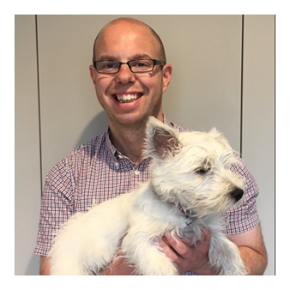
James Skinner – Recording Secretary, UK 2014 - 2022
James Skinner acted as the recording secretary for the IPFD, taking minutes at meetings and teleconferences. He has worked for the Kennel Club and finally got his first ever dog, Bertie the Westie, in July 2018.

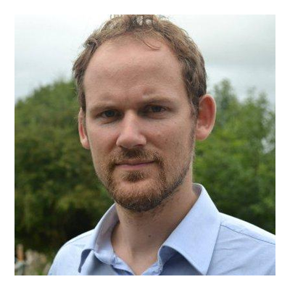
Gregoire Leroy – Board od Directors, Collaborator, France 2015 - 2019
Grégoire Leroy holds a PhD in animal genetics. His research activities focus on characterization, sustainable management and conservation of animal genetic resources. Academic: PhD, HdR 43 peer reviewed publications; 6 chapters in book; 6 books or reports. View Grégoire's Blog <https://dogwellnet.com/blogs/blog/6-gregoire-leroys-blog/ > on DogWellNet.com.
Formerly:
Assistant professor at AgroParisTech and currently seconded to the Food and Agriculture Organization of the United Nations
Société Centrale Canine (French Kennel Club): Scientific Commission, member
Société Centrale Canine (French Kennel Club): Breeding Commission, member
Fédération Cynologique Internationale: Scientific Commission, member
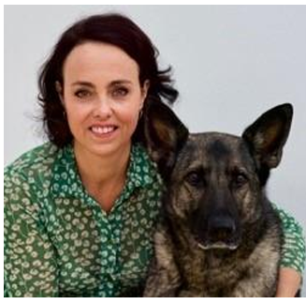
Monique Megens – COO, Spain 2019-2020
Graduating from Utrecht University, The Netherlands (1998), Monique started her career as a companion animal veterinary practitioner. In 2008, she sold her clinic to work as an independent project manager and consultant. Monique has been involved in veterinary politics in Europe for many years, serving among many positions as the President of the Federation of European Companion Animal Veterinary Associations (FECAVA). On behalf of FECAVA, she was a member of the joint Union of European Veterinary Practitioners (UEVP) & Federation of Veterinarians of Europe (FVE) Animal Welfare Working Group. She was responsible for the European veterinary position paper on stray dogs, the position paper on (il)legal dog trade, and the position paper on the responsible breeding of dogs. Monique has been a speaker on these topics at many international conferences. Currently, she is a member of the World Small Animal Veterinary Association (WSAVA) Hereditary Disease Committee, a member of the Health Committee of the Dutch Kennel Club, and Chair of the International Working Group on Extreme Conformation in Dogs (IWGECD).

