The International Partnership for Dogs (IPFD)
2022 Milestones through June - Report to Partners
Addressing the big picture for dog health and welfare
Key Stakeholders: Kennel and Breed Clubs, Breeders; Legislators and Regulators; The Public/Consumers; Veterinarians and the Veterinary Profession; Researchers/Research Institutions; The Pet Industry; Welfare Organizations/Shelters; Producers/Distributors.
IPFD: IPFD was initiated by major kennel clubs (KCs) and key pet industry groups – true leaders in the world of dogs – who shared a commitment to maintaining and improving the health of all dogs.
IPFD takes a multi-stakeholder, Big Picture approach to the complex challenges of dogs, breeds, and human-dog interactions; works to provide resources, inform, assist in actions for health and welfare, and bring these stakeholder groups into collaboration and cooperation. IPFD is a unique international organization that can operate at arms length, independently and transparently, to address the breadth of challenges in dog (pedigree and non-pedigree) health and welfare.

Information Sharing and Collaboration 2022
Genetics and Genetic Testing: Since its launch in 2018, IPFD’s Harmonization of Genetic Testing for Dogs (HGTD) has grown to include information on 82 international genetic test providers (GTPs) with 45 actively participating in 23 countries. The database includes all the major phenes (tests) sold for use in dogs and is integrated with latest research and clinical information, with additional breed-specific information on test usage or application in the breed(s).
In addition to providing a searchable database of GTPs, breed-specific genetic testing information complied for HGTD is being integrated into Get a GRIHP! documents, a series of articles on the Big Picture of health and welfare within specific breeds.
Beyond the numbers and specific actions, IPFD and HGTD contribute to the overall quality, consistency, and
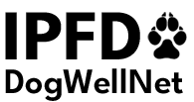

accuracy of data on genetic testing for dogs. We help improve communication on genetic testing and counseling and bring together national and international stakeholders including researchers, veterinarians, genetic test providers, kennel club advisors, breeders, and owners.
Further genetic testing and counseling resources are available in articles and blogs by HGTD Project Manager Aimee Llewellyn-Zaidi (Ask Aimee | HGTD & Genetic Testing).
Virtual International Dog Health Workshops: On May 3, we hosted our second virtual workshop, Genetic Diversity. Focusing on genetic diversity primarily from a genetic tests/tools view, 60 participants – including representatives from IPFD and our Partner kennel clubs, genetic test providers, breeders, and other key stakeholders – came together online to identify genetic diversity tools and resources, and to discuss priorities and actions for the benefit of all dogs.
A very special thank you to our distinguished panel, which included Prof. John Woolliams (The Roslin Institute, UK), Samantha Hauser (Embark, USA), Katy Evans (Guide Dogs, USA), Saija Tenhunen (Viking Genetics, FI), Pieter Oliehoek (Dogs Global, NL), and Sally Ricketts (University of Cambridge, UK), for sharing their time and expertise with us!
An immediate outcome from this workshop was collaborative invitation to work with the Nordic Kennel Union (NKU/VK) to develop a compendium of genetic diversity tools and resources. We’re in the process of determining further next steps (e.g., working groups, subsequent workshops) on genetic diversity issues and will update workshop participants and stakeholders shortly.
We are currently planning our third virtual workshop on Extremes of Conformation, to be held in conjunction with further discussions on current challenges around Parentage Testing (and kennel clubs’ practices in this area) in the Fall of 2022. Stay tuned for details!
Breed Specific Work – A Core IPFD Activity
Get a GRIHP! on Breeds: Our 2022 Breeds of the Month featured links to our Pedigree Breeds Database, which now contains updated information, videos, links to kennel and breed clubs on 183 breeds as well as links to other content on DogWellNet.com, such as:
Get a GRIHP! Globally Relevant Integrated Health Profiles (GRIHPs), describe the Big Picture of health on (all) conditions that are of interest within a breed. Get a GRIHP! breeds for 2022 include (so far) Whippets, Belgian Shepherds, English Bulldogs, and Irish Soft Coated Wheaten Terriers.
All include information on national populations, breed statistics – including from our Partner Agria, health strategies from Swedish RAS, and Finnish PEVISA and JTO documents; as well as recommended/required health tests from the UK, Sweden, Finland, and USA, and, more recently, from France, Germany, and the Netherlands.
GRIHP articles are published in concert with Meet the Breed presentations by IPFD Collaborating Partner, the World Small Animal Veterinary Association (WSAVA) in their Bulletin newsletter.

Highlighting Actions by Partners
Digest: Our Digest e-newsletter is published several times a year. Each issue includes a special Partners in Action section highlighting news from our Partners and contributors.
Blogs: Focus on issues timely and relevant to key stakeholders, such as breeders. Examples include:
- WSAVA Calls for ‘Health-focused’ Breeding
- Norway dog breeding bans – what can you do to save your own breed?
- Breeding healthy puppies & sustaining your breed: the goal & how do you get there?
- The Downside of Inbreeding
- Kennel Clubs and Responsible Breeding: Examples from Finland
- Genetic diversity tools in the Finnish Kennel Club's breeding database
Social Media: We frequently post and share content on our Partners’ activities to our social media channels.
Getting the Balanced, Big Picture Message Out
Our Multi-Pronged Approach: Via DogWellNet.com, IPFD's outreach, and International Dog Health Workshops/Virtual Workshops, our aim has been to collect and present evidence-based data, highlight Kennel and Breed Club tools and programs and resources, and share common sense content that promotes health and wellness for purebred dogs and all dogs.
We have engaged experts in breeds, involved genetic and canine researchers as well as featured materials from health and welfare sectors, industry/pet insurance/ genetic test providers and the veterinary organizations/fields.
We provide centralized venues in which the canine communities across borders can come together to explore methods and means to understand improve dog's lives. Through engaging experts, we have been successful in highlighting the work of our partners that directly serves and enhances value added human canine connections.
We are thrilled to spotlight our Partners’ and Collaborators’ efforts on behalf of dogs and to keep lines of communication between stakeholders open and productive.
WSAVA Bulletin: IPFD’s regular Meet the Breed submissions update veterinarians with information on a variety of healthy and challenged breeds. Four breeds have been featured in 2022 as of June. Along with breed and health information in each edition are links to our Get a GRIHP! Articles, highlighting the work of breed and kennel clubs.
Key Presentations: By IPFD Veterinary Science Officer, Dr. Brenda Bonnett:
- SJDAWC Animal Welfare Concerns with Dog Breeding webinar series, 15 March International Challenges for Dog Breeding: How do Veterinarians Navigate the Complexities of Health, Welfare, and Owner Attachment?.
- Embark Canine Health Summit, 27-28 April Breeding healthy puppies and sustaining your breed: the goal and how do you get there?.

IPFD Editorial in Our Dogs: On May 13, Our Dogs newspaper published an opinion piece entitled: Need for international leadership on recent events relative to dog shows in Germany and other legislative and legal actions against certain breeds of dogs. They mention the potential for IPFD to have a role in promoting pedigree dogs, kennel clubs, and dog shows.
Our response, IPFD and Pedigree Dogs – You want leadership? We are ready, appeared in Our Dogs on May 18. The published version is only available to Our Dogs subscribers, but it is reprinted and available as a PDF here on DogWellNet.com.
Excerpt:
“Responsibility means being fully accountable for health and welfare: recognizing problems in some breeds and ensuring that these are effectively addressed and demonstrating a commitment to maintaining and improving the health of all breeds. There has been denial of scientific, evidence-based information, because it goes against the desires or ‘traditions’ of some in the show world. The rest of the dog community. (e.g., veterinarians, welfare groups, legislators) understands that people are passionate about the hobby or business of dog shows; what they are looking for is proof – not merely proclamations - that concerns for the dogs come first.”
Complex situation for Brachycephalic breeds – IPFD receives many requests for information on, and participation in, this issue:
The Balanced Message:
- Kennel and breed clubs have a responsibility to address current and future health problems in these breeds – HOWEVER…
- They cannot be alone in these efforts. Most dogs in most countries are produced outside of kennel Club influence. Many actions by legislators, welfare groups, and veterinarians are narrow and short sighted and will spawn unintended consequences.
- These items are stressed repeatedly in articles on DogWellNet.com, in presentations to vets, vet organizations, welfare groups and articles in veterinary media.
- What other organizations that are NOT kennel clubs are driving home these points?
- How many are pushing veterinarians to collaborate with breed clubs and kennel clubs?
- There are several well-recognized, compromised breeds and many relatively healthy pedigree breeds.
IPFD tries to maintain that balance in all discussions.
IPFD’s Role: Promote collaboration; keep breeders and kennel clubs and other stakeholders aware of international developments
- In the absence of cooperation and collaboration, we are seeing unilateral actions by:
  - Legislators – e.g., in Germany, The Netherlands, and Norway
  - Veterinarians – e.g., petitions, videos
  - Welfare groups – public campaigns, legal action
IPFD is at a crucial point, as are the rest of you. We stand ready to lead, assist, and promote healthy pedigree dogs together with any KCs who are committed to doing the work needed. Please join us!
- Point out errors and inappropriate; highlight the complexities – in discussions with other stakeholder groups, e.g., humane and vet organizations.
- There are many, many brachycephalic dogs – popularity has surged. This is causing stress among veterinarians dealing with increased health and welfare problems.
- Many dogs of certain breeds have significant health issues due to their conformation.
  - Are most dogs from pedigree breeders? No. Even if many owners think their dog ‘has papers’, etc.
  - Are all pedigree dogs free of these problems? No.
  - What influence do pedigree breeders and breed standards have on people wanting to own these dogs? Unknown.
  - How can we improve the health of all dogs?
What can pedigree breeders and kennel clubs do to lead and protect health and welfare? Some are being very proactive. Some have been terrific leaders, especially in the recent past. The pedigree world leading in stewardship is so needed.

Our People

IPFD CEO: Dr. Katariina Mäki continues as Acting CEO, and the IPFD Board is working to select a permanent candidate for the role.

The Board:
Pekka Olson, former President SKK, Veterinarian, Chair
Bill Lambert, The Kennel Club, UK, Vice Chair
Alexandre Balzer, President SCC, France
Peter Friedrich, President VDH, Germany
Barbara Thiel, Veterinarian, Germany
Marty Greer, Veterinarian, USA
Dave Eikelberg, BRTCA member, USA
Kirsi Sainio, University of Helsinki, Finland
View profiles of our Board and Consultants here

Key Links
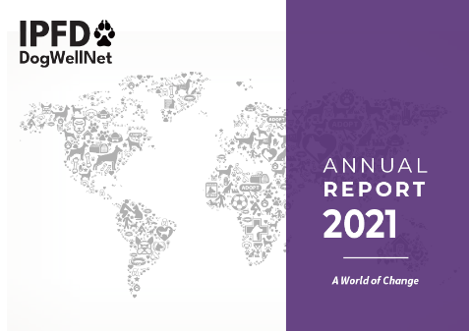

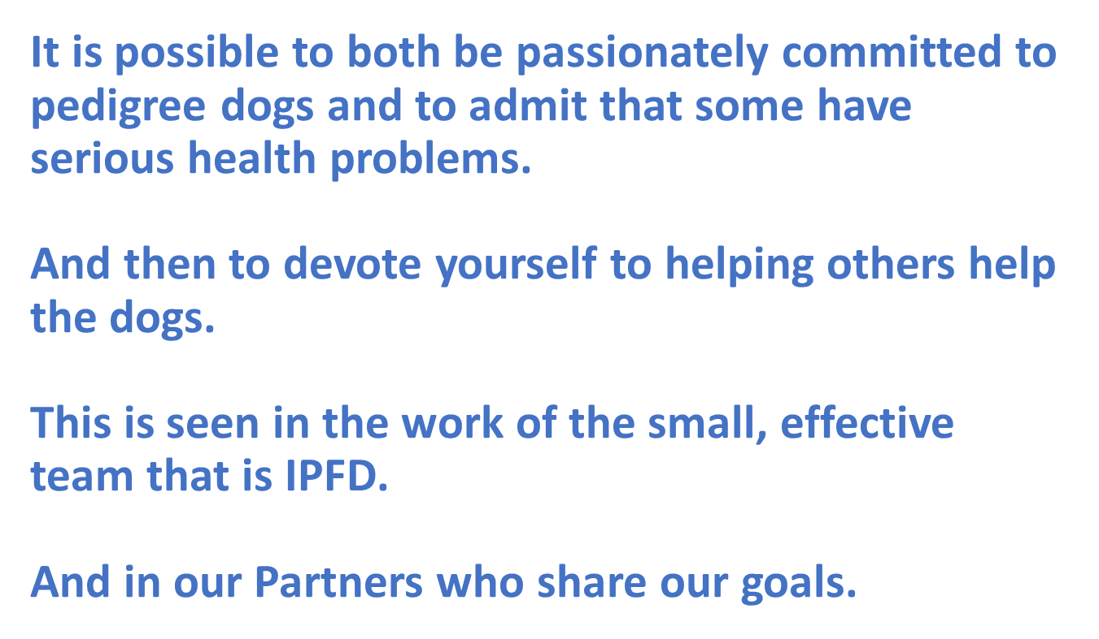
IPFD Annual Report 2021: A World of Change

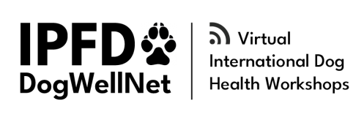

IPFD Virtual International Dog
Health Workshops 2021-22

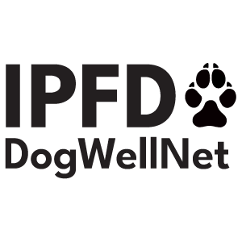
International Partnership for Dogs
c/o Svenska Kennelklubben
Box 771, 191 27 Sollentuna Sweden
www.dogwellnet.com | info@ipfdogs.com

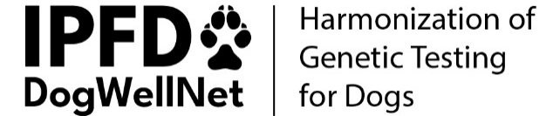

IPFD Harmonization of Genetic Testing for Dogs (HGTD)

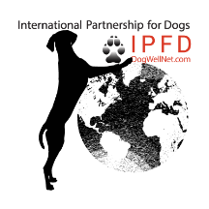
Think Globally, Act Locally
Reframing Current Challenges Around Pedigree Dogs: A Call for Respectful Dialogue, Collaboration, and Collective Actions

