Letko, A., Minor, K.M., Jagannathan, V. et al. Genomic diversity and population structure of the Leonberger dog breed. Genet Sel Evol 52, 61 (2020). https://doi.org/10.1186/s12711-020-00581-3
Review and highlights of key sections – especially findings that inform possible actions. Generally an The structure of the study, its scope and findings can be used to promote discussion in other breeds. Breeders and breed clubs must be open to address the issues and implement such actions if they want to change the situation in the breed.

Excerpts from paper | Take away messages | Actions
Background  Leonberger is a giant dog breed formed in the 1850s in Germany. Its post-World War II popularity has resulted in a current global population of ~ 30,000 dogs. The breed has predispositions to neurodegenerative disorders and cancer, which is likely due in large part to limited genetic diversity. However, to date there is no scientific literature on the overall demography and genomic architecture of this breed. | - The breed has predispositions to neurodegenerative disorders and cancer, which is likely due in large part to limited genetic diversity.  - However, to date there is no scientific literature on the overall demography and genomic architecture of this breed. | - Implies that common sense, expert opinion and/or experience interpret such predispositions as indicative of a lack of genetic diversity. Presumably one could add issues like reproductive problems (e.g. low litter size and other accepted indications of inbreeding depression), and sub-optimal or decreasing lifespan.  - And so… scientific study is need to provide stronger evidence, on top of the rather obvious implications above.
Results  We assessed [basic study design and sample populations]  - extensive pedigree records, (N=142,072)  - SNP array genotype data (N= 1203)  - whole-genome sequences (WGS) (N=39)  - Pedigree analyses identified 22 founder animals and revealed an apparent popular sire effect.  - The average pedigree-based inbreeding coefficient of 0.29 and average kinship of 0.31 show a dramatic loss of genetic diversity.  - The observed average life span decreased over time from 9.4 years in 1989 to 7.7 years in 2004.  - A global health survey confirmed a high prevalence of cancer and neurological disorders.  - Analysis of SNP-based runs of homozygosity (ROH) identified 125,653 ROH with an average length of 5.88 Mb, and confirmed an average inbreeding coefficient of 0.28.  - Genome-wide filtering of the WGS data revealed 28 non-protein-changing variants that were present in all Leonberger individuals and a list of 22 potentially pathogenic variants for neurological disorders of which 50% occurred only in Leonbergers and 50% occurred rarely in other breeds. Furthermore, one of the two mtDNA haplogroups detected was present in one dog only | 1 – 3  Note the 3-pronged approach, allowing comparison across older (pedigree) and newer (genetic and genomic approaches) that also supports use of much higher numbers of dogs.  - Note that the 39 dogs in the WGS work all had polyneuropathies and were chosen as effective support discovery of possible disease causing genes. Informative, but not necessarily representative of the wider population – except given the high relatedness found, in general, probably somewhat typical.  - (and 5) This tells you about the past behaviours/ breeding practices that were embraced in the selection of animals by pedigree breeders – i.e., active line/inbreeding and overuse of specific individuals (as well as underuse of a wider population of potential reproducers).  - Again, what you see is what you got. And I believe their estimates are based on owner-provided data. Unknown, but might be a little worse in reality.  - Which was probably NOT a surprise to the breeders/breed clubs and owners.  - In this case the genomic estimate of inbreeding is similar to the pedigree data. Could be for various reasons including: the relatedness of the population, vast amount of pedigree data, etc.  - Used primarily to look for new causative genes/tests. But there is also an indication of underlying relatedness. | Congratulations to the international Leonberger community.  Something to think about for other clubs who might contemplate a similar study.  - Costs and resources  - Engagement and number of participants and dogs internationally  - But, perhaps stop and consider – what do you already know about your breed. If you know the population of your breed shares some of the key characteristics mentioned above – you could start to embrace better practices, even without the results of such a study.  - Major benefit of such a study is the information on whether or not there is adequate diversity (numbers of unrelated dogs) from which to breed AND providing a baseline of evidence from which to monitor progress (more information below).  - Again – are breeders and breed clubs going to change the behaviours that created the current situation??  - (and 5) What you see is what you got from what you did. In the Leonberger, a sudden increase in popularity following genetic bottleneck had deleterious effects. Ultimately, though, breeders chose to ‘over breed’ on limited numbers of breeding animals in order to supply the demand, or their desires.  It is likely that informed and experienced breeders within a club already have a very good idea about influential and overused sires and even an indication on the level of line/inbreeding that has been done, at least in their region or country. Transparency and acknowledgement are needed.  - It is great to generate evidence on prevalence of disease and lifespans and this is needed for monitoring. However, pretty clear anecdotal, expert and experiential information may already be available and the picture fairly clear.  - Always some caution on owner-related causes of death – tendency to e.g. report ‘old age’ if the dog lived to what is accepted as an average age for the breed. Also, to report on, e.g. their longest-lived dog(s). Such survey information is still useful, but should be viewed as generally ‘conservative’ and possibly optimistic.  - This will come up again later in the article when the authors describe why/how it will be difficult to find enough unrelated animals to ‘breed out of’ the current situation.
Conclusions  - The increasing size of the Leonberger population has been accompanied by a considerable loss of genetic diversity after the bottleneck that occurred in the 1940s due to the intensive use of popular sires resulting in high levels of inbreeding.  - This might explain the high prevalence of certain disorders; however, genomic data provide no evidence for fixed coding variants that explain these predispositions. The list of candidate causative variants for polyneuropathy needs to be further evaluated.  - Preserving the current genetic diversity is possible by increasing the number of individuals for breeding while restricting the number of litters per sire/dam. In addition, outcrossing would help optimize long-term genetic diversity and contribute to the sustainability and health of the population. | - Clearly stated. This was paraphrased above: breeders started with a limited (and possibly already related) population of dogs, bred like mad to satisfy a sudden and growing demand, focused to a great extent on popular sires, and used high levels of inbreeding.  - It may have, although it is not clear (i.e. there are not a limited number of fixed genes that explain causation of the one disease they looked at) however, a contribution to health issues and decreased lifespan is possible and at least to some extent logical. Even if some claim that there was not the knowledge about the perils of line/inbreeding, it is clear now.  - In the article, the authors provide more information on whether there are sufficient unrelated dogs from which to breed. And of course, then must be identified (and there are programs in various countries to work towards reducing COIs, etc.  Many authors are loathe to speak out strongly for outcrossing, knowing the attitudes within the pedigree dog community. But planned, well-organized outcrossing may be needed. Many warn, and it is borne out by this study, that simply selecting animals with geographic separation will not guarantee unrelatedness. | - Breeders and breeding practices directly contributed to the loss of genetic diversity. Breeds sharing a somewhat history and background to the Leonberger, may do well to assume there would be similar indications in their breed.  - (and 3) What is the responsibility of breeders and breed clubs now/ If they plan to carry on as before, they must accept responsibility for the outcomes and not sigh and cry about sick animals dying too young as if the cause is a mystery. If they feel that the situation is acceptable, they should at least step up and openly acknowledge that they are choosing, e.g. show goals, their hobby, tradition or whatever, over health and longevity and improved sustainability of the breed through more diverse and informed practices.  If they want to make improvements, the community must embrace the actions outlined.

Other Evidence from Agria Breed Profiles.
2011-2016
Leonberger: almost 2 times increased mortality rate compared to All Breeds.
Median age at death Leonberger: 6.7 ; All Breeds 7.4; Male Leonberger higher mortality compared to females, and bigger difference than for All Breeds.

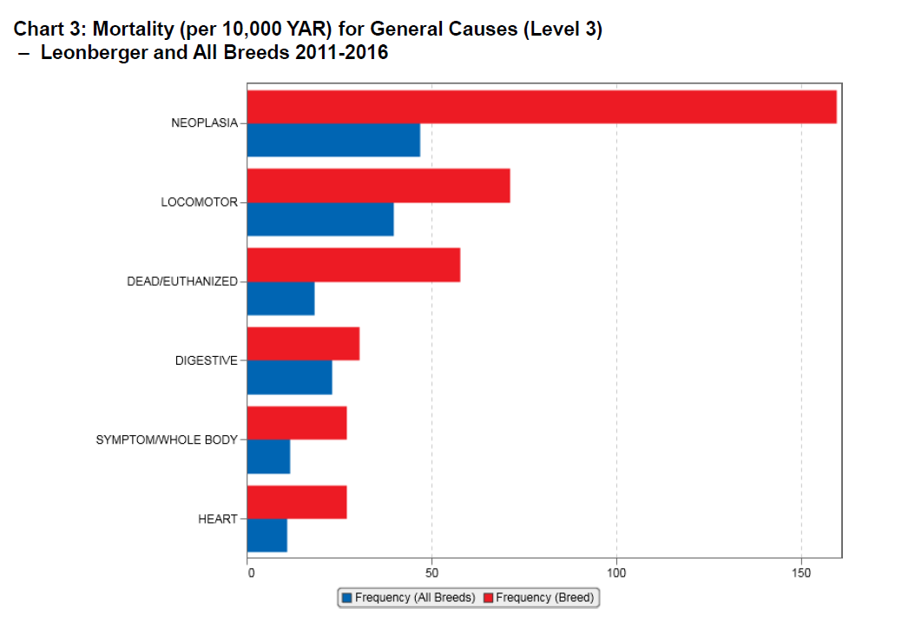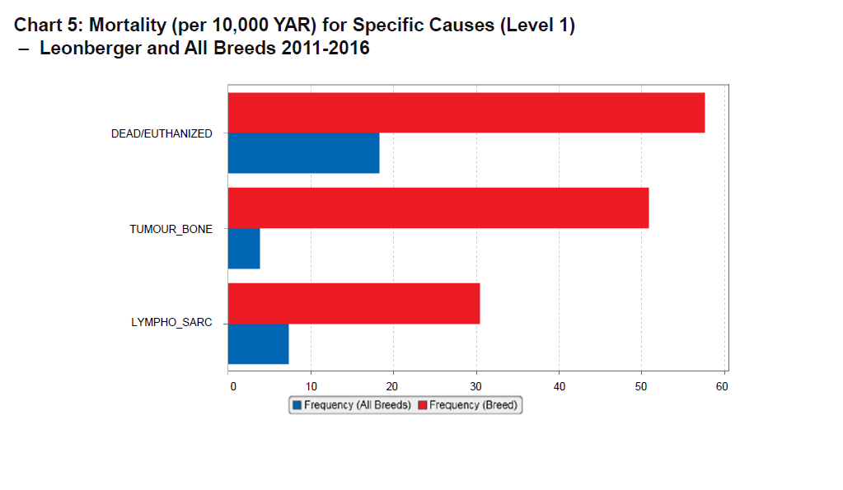

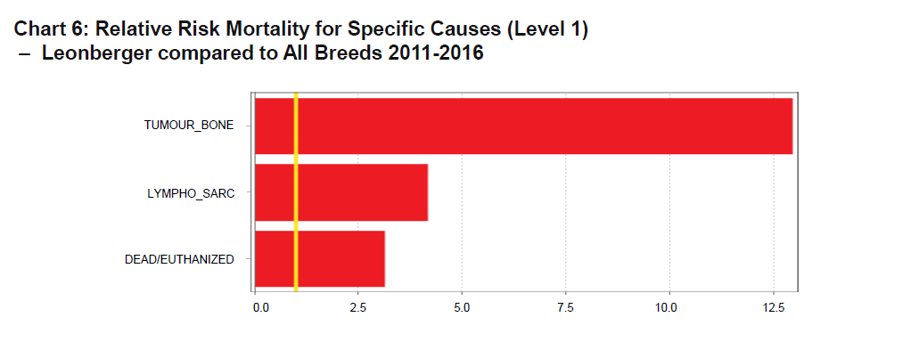

Morbidity:

Not as big a difference as compared to Mortality. But many similarities to article.

