Basset Hound Coat Color DNA Study

This page was mounted January 25, 2011 and was last updated January 5, 2013 by Dayna Dreger, PhD. The linked pages in this series by Sheila Schmutz (sheila.schmutz@usask.ca) may have been updated more recently.

Special thanks must be extended to the Basset Hound Club of America for allowing me to attend their 2010 National Specialty in order to collect samples for our studies. The assistance of Jane Baetz, Norine Noonan, and the members of the Fort Dearborn Basset Hound Club and the Badgerland Basset Hound Club is much appreciated.

Basset Hound Colors
The Basset Hound breed standard indicates that "any hound color" is acceptable, though only a handful of colors actually exist within the breed. Breed colors include "tricolor", "black and white", "black tri", "lemon and white", "red and white" and "mahogany". These terms can be misleading, as there is noticeable overlap between the colors. The white markings can be termed "blanket" or "open", though it is not always easy to determine a blanket dog from an open dog.

E Locus (MC1R)
The E locus has 4 alleles: E^{M}, E^{G}, E, and e.
The E^{M}, E and e alleles are present in the Basset Hound breed. The E allele allows for the production of both red and black pigments, so is present with the majority of color patterns in Basset Hounds.
Red and Lemon
The Red and Lemon colors are caused by the e allele of MC1R. This is a recessive allele, so red and lemon dogs are homozygous e/e. Lemon dogs are lighter in color than Red dogs. The genetic mechanism that dilutes phaeomelanin in this instance is unknown. Absolutely no black hairs will be present on either Red or Lemon dogs.
Ruby, below, is red and white.
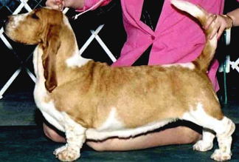
Black Mask
The E^{M} allele produces a melanistic (black) mask on the face that covers the muzzle and can extend up around the eyes and onto the ears. This pattern is most easily seen on Mahogany dogs, though any Basset Hound pattern may express the E^{M} allele, except for "red and white" or "lemon and white" due to e/e.
Norman (below left) is heterozygous for the E^{M} allele and has a black mask on his muzzle. Compared to Dozer (below right) who does not have a black mask.
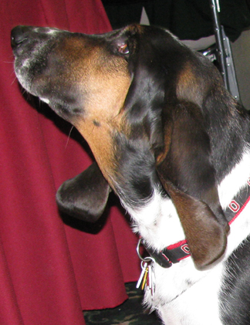 | 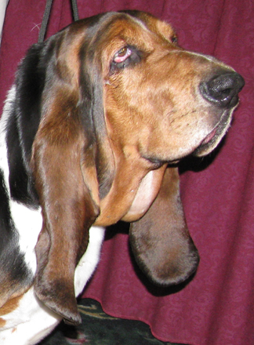

A Locus (ASIP)
There are 4 alleles of ASIP: a^{y}, a^{w}, a^{t}, and a.
Basset Hounds have two of these alleles: a^{y} and a^{t}.
Tricolor, Black Tri, Black & White
These three color terms all refer to patterns caused by the a^{t} allele of ASIP. This allele produces a pattern of black pigment over the body of the dog, with tan colored points on the legs, cheeks, eyebrows, chest, and beneath the tail. Note that white markings can obscure tan points. Ticking on white patches will indicate if the underlaying region has black or red pigment.
Black Tri and Black & White are the same pattern, though the two names are often used interchangeably within the breed. Genetically, we would classify both of these patterns as "black-and-tan".
Marvin (below left) and Elwood (below right) are both black-and-tan Basset Hounds. They are both a^{t}/a^{t} at ASIP. Note that Elwood also has piebald white spotting which obscures most of the pigment on his body. You can still distinguish the tan points on the legs by the red color of the ticking. His melanistic mask is also minimized by the white on his face
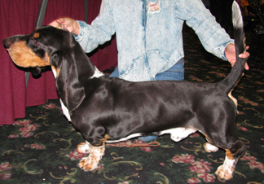 | 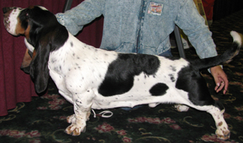
Saddle Tan
Some dogs express a "saddle tan" phenotype, often termed "tricolor" or "red headed tri" within the breed. These dogs are a^{t}/a^{t} at ASIP, so they are technically black-and-tan as well. They differ from the previously mentioned black-and-tan dogs in that the tan points have expanded to cover the head and ears, and often up the shoulder to the withers, and up the hind leg to the hip. The genetic mechanism that causes the tan points to expand to form the saddle tan phenotype is not yet known.
Ginny (below left) and Gracie (below right) are both saddle tan Basset Hounds. Notice that Gracie has piebald white spotting which covers much of her body. It can be difficult to determine if a dog is traditional black-and-tan or saddle tan in cases such as this. We can determine that Gracie is saddle tan because her head is predominantly red, without the distinctive tan cheeks and eyebrows seen in traditional black-and-tan dogs. Red pigment can also be seen in the ticking high on her shoulder and on the pigmented patch on her flank. If she were a traditional black-and-tan pattern, these pigmented patches would be solid black in color. Pedigree analysis indicates that saddle tan is dominant to traditional black-and-tan, though both phenotypes must also be a^{t}/a^{t} at ASIP.
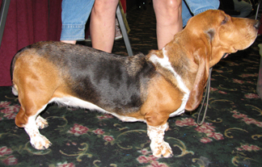 | 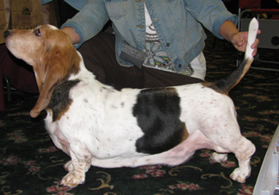
Mahogany
Mahogany Basset Hounds are red, often with a few black hairs on the body or face. The overall color of Mahogany dogs tends to appear darker in color than what is seen in Red or Lemon dogs, though this is not a foolproof way of distinguishing Mahogany from Red. It is likely a result of black tipped hairs spread over the body in Mahogany dogs.
Mahogany is caused by the a^{y} allele of ASIP, which is dominant to a^{t}.
BB, below, was submitted for this study as a Red & White Basset Hound. Testing revealed that she is, in fact, a^{y}/a^{t} Mahogany. No black hairs are apparent in her coat from the photograph. This could lead to confusion as, if she were bred to a black-and-tan male, she would produce approximately 50% "red" puppies (actually Mahogany) and it could be assumed that the male were carrying the e allele of MC1R, which may not be true in reality.
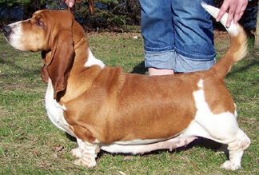
Stachie (below left) and Twister (below right) are both Mahogany Basset Hounds. Both are a^{y}/a^{t}, expressing the dominant a^{y} allele and carrying the a^{t} allele for black-and-tan. Twister has noticeable black hairs on his face due in part to also having the melanistic mask E^{M} allele of MC1R, while BB (above) and Stachie do not.
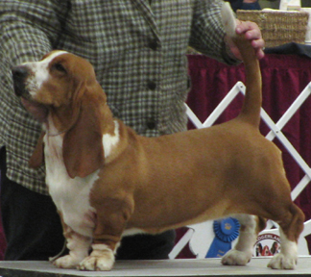 | 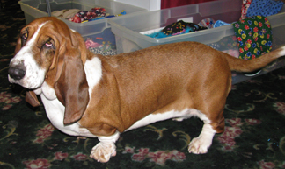

Color | E Genotypes | A Genotypes
Mahogany with Black Mask | E^{M}/(E^{M}, E, e) | a^{y}/(a^{y}, a^{t})
Mahogany without Black Mask | E/(E, e) | a^{y}/(a^{y}, a^{t})
Black-and-Tan with Black Mask | E^{M}/(E^{M}, E, e) | a^{t}/a^{t}
Black-and-Tan without Black Mask | E/(E, e) | a^{t}/a^{t}
Red or Lemon | e/e | (a^{y}, a^{t})/(a^{y}, a^{t})

White Spotting
Two white spotting patterns are present in the Basset Hound breed. All Basset Hounds are fixed for Irish spotting, which has white on the paws, chest, collar, and tail tip. The size of these white markings can vary noticeably.
Fred (below left) has very minimal white markings on his paws and chest. Dozer (below right) has white markings that cover more of his legs, chest, and around the collar. Both of these dogs would be termed "blanket" within the breed, but from a genetics standpoint are considered to have Irish spotting.
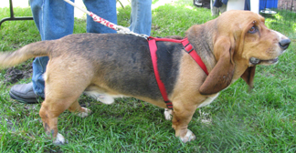 | 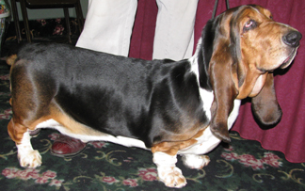
In addition to Irish markings (blanket), Basset Hounds can have piebald white spotting as well. Within the breed, this is termed "open". Piebald, or open, white markings often cover a larger amount of the body of the dog, extending up the sides and over the back. This pattern in many other breeds is determined by a mutation in the MITF gene. However, this mutation does not explain the white patterns in Basset Hounds. The cause of white spotting in Basset Hounds is currently unknown.
Amulet (below left), Hurricane (below center), and Isabella (below right) are typical examples of "open" Basset Hounds.
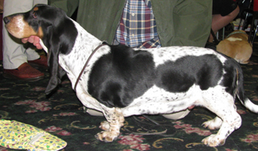 | 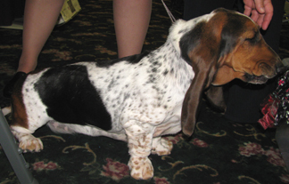 | 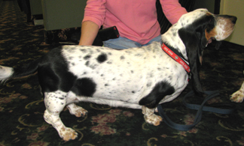
Distinguishing between "blanket" and "open" marked Basset Hounds can be difficult. Some dogs have a small amount of white on their back or up their flanks that may suggest that they are minimally marked "open" dogs.
Spot (below left) has a small patch of white on his back. Anna (below center) has white up her ribcage and a strip of white across her hip. Giotto (below right) has a strip of white up his flank. All of these markings are more than what is associated with Irish markings (blanket), but are not as dramatically white as the above piebald (open) dogs.
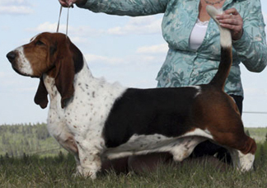 | 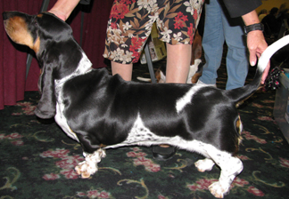 | 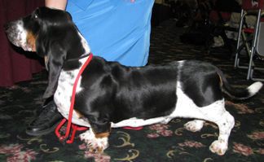

Long Hair
Long hair does exist within the Basset Hound breed, though it is very uncommon. Cadieu et al. (2009) have identified three gene variants that affect coat type. It is not yet known if any of these genes are responsible for the long haired phenotype in Basset Hounds.
Gabby (below) is a long haired Basset Hound.
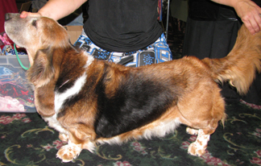

Further Reading:
Schmutz SM, Berryere TG, Ellinwood NM, Kerns JA, Barsh GS. 2003. MC1R studies in dogs with melanistic mask or brindle patterns. Journal of Heredity. 94:69-73.
Berryere TG, Kerns JA, Barsh GS, Schmutz SM. 2005. Association of an Agouti allele with fawn or sable coat color in domestic dogs. Mammalian Genome. 16:262-272.
Cadieu E, Neff M, Quignon P, Walsh K, Chase K, Parker HG, Von Holdt BM, Rhue A, Boyko A, Byers A, Wong A, Mosher DS, Elkaloun AG, Spady TC, Andre C, Lark KH, Cargill M, Bustamante CD, Wayne RK, Ostrander EA. 2009. Coat variation in the domestic dog is governed by variants in three genes. Science. 326:150-153.
Karlsson EK, Baranowska I, Wade CM, Salmon Hillbertz NHC, Zody MC, Anderson N, Biagi TM, Patterson N, Rosengren Pielberg G, Kulbokas III EJ, Comstock KE, Keller ET, Mesirov JP, von Euler J, Kampe O, Hedhammar A, Lander ES, Andersson G, Andersson L, Lindblad-Toh K. 2007. Efficient mapping of mendelian traits in dogs through genome-wide association. Nature Genetics. 39:1321-1328.
Schmutz SM, Berryere TG, Dreger DL. 2009. MITF and white spotting in dogs: a population study. Journal of Heredity. 100:S66-S74.
Dreger DL & Schmutz SM. Proposed evolution of the agouti locus alleles in domestic dogs. Advanced in canine and feline genomics and inherited disease conference in Baltimore, MD. September 23-25, 2010.
Dreger, D. L. and Schmutz, S. M. 2011. A SINE insertion causes the black-and-tan and saddle tan phenotypes in domestic dogs. Journal of Heredity 102:S11-S18.
Dreger D.L., Parker H.G., Ostrander E.A., and Schmutz S. M. 2013. Identification of a mutation that is associated with the saddle tan and black-and-tan phenotypes in Basset Hounds and Pembroke Welsh Corgis. Journal of Heredity 104:399-406.

Links
Dog Coat Color Genetics Main Page

